***It all starts with a shake, which becomes hope for a healthy life and a better future.***

The Reliv Kalogris Foundation

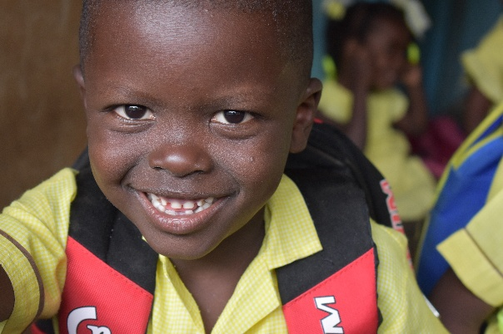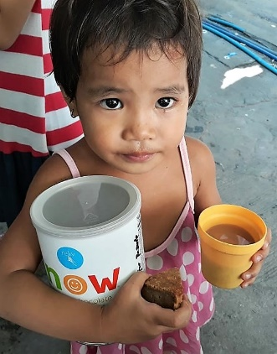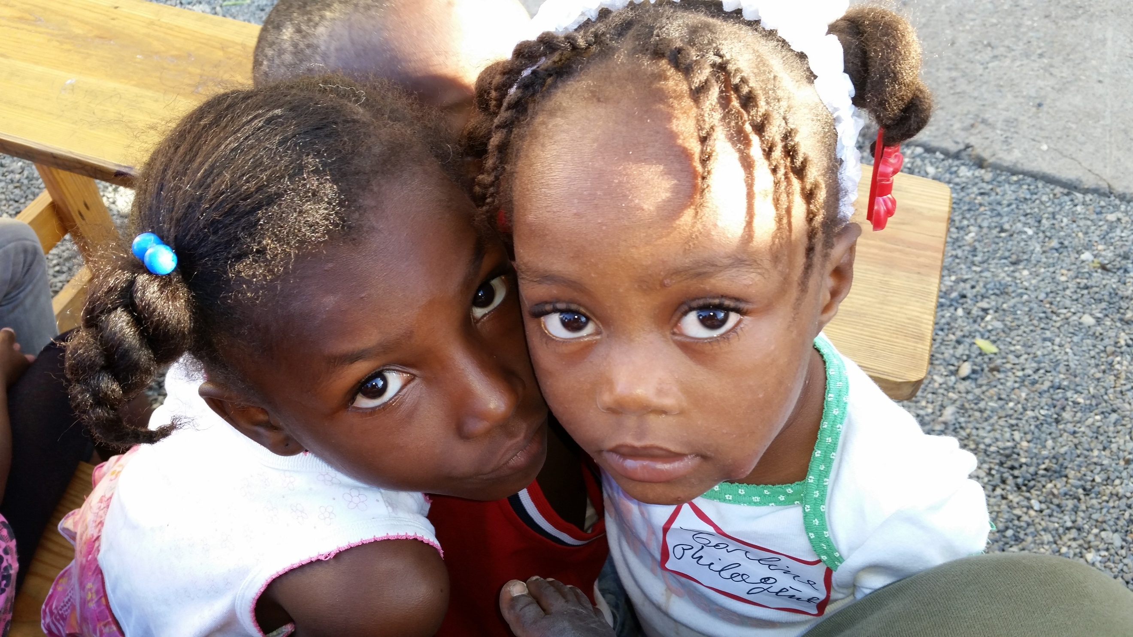

* We provide nutrition to **25,660** individuals in 8 countries.
* Most of our nutrition programs are located in schools, churches, and clinics run by **700** dedicated volunteers.
* The Foundation currently distributes **2.4 million** shakes to RKF participants per year.
* Each year, more than **95%** of donations go directly to support program services - well above the 75% criteria established by the *American Institute of Philanthropy.*

To donate, please visit [**www.relivkalogrisfoundation.org**](http://www.relivkalogrisfoundation.org)

**Venmo: @RKF_reliv95 PayPal**

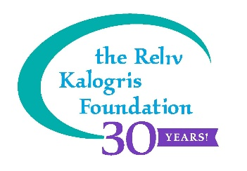

***136 Chesterfield Industrial Blvd.***

***Chesterfield MO, 63005 636.733.1395***

***RKF@relivinc.com***

*Reliv International established the Kalogris Foundation in 1995 as a non-profit, 501(c)(3) charitable organization, named in honor of the late Dr. Theodore Kalogris who created the original nutritional formula that is Reliv Classic®.*